CARESTREAM HEALTH
Change History
Revision | Description of Change | Revision Date
0.1 | Initial draft | 3/15/2015

Table of Contents
1 Introduction 3
1.1 Purpose 3
1.2 References 3
1.3 Acronyms 3
2 Software Configuration 4
2.1 Console PC serial ports and MOXA ports configuration. 4
2.2 Generator firmware update and configuration 5
2.3 Can Analyzer Drivers 8

Introduction
  - Purpose
The purpose of this document is to introduce software configuration of the virtual evolution lab system.

  - References
Below list the essential related documents used as sources of information, as a basis for understanding, and/or as origins of specific requirements.
Documents | Part Number | Revision
Virtual Evolution Lab System User Guide |  | 1.0
Virtual Evolution Lab System Hardware Installation and Configuration Guide |  | 1.0

Acronyms

Abbreviation | Meaning
GUI | Graphic User Interface
CAN | Controller Area Network
GUI | Graphical User Interface – What the end user sees.
WSD | Wall Stand Axis Controller
TBL | Table Axis Controller
OTC | Over Tube Axis Controller
PCU | Power Control Unit

Software Configuration

Console PC serial ports and MOXA ports configuration.
Set the ports’ number as shown below (HP5800):
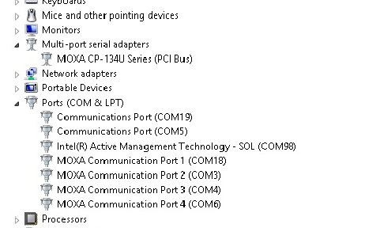
“COM19” and “COM5”: used for UPS communication.
“COM18”: used for UPS board control interface.
“COM3”: used to connect with generator.
Note: Please make sure the MOXA port 1 and 2 are all set to RS232 mode as below.
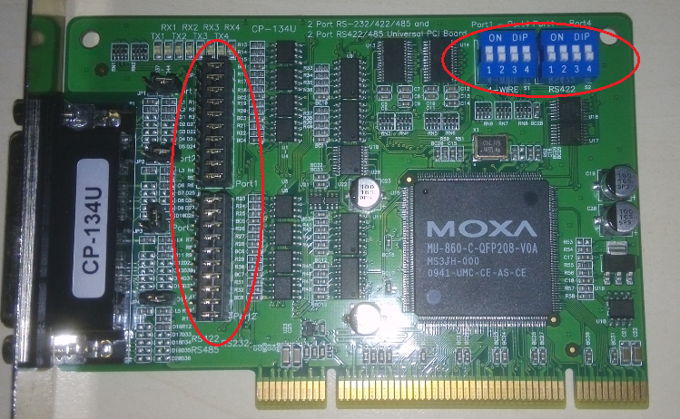

Generator firmware update and configuration
1. Power up the generator and run Everest service tool. Use “COM3” for connection.
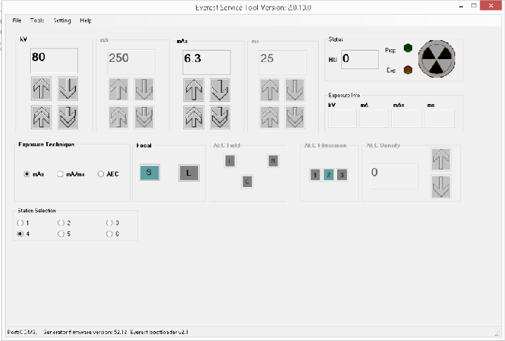
2. Select “Login” and log in the service tool with password “62335”
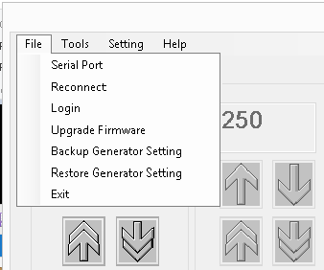
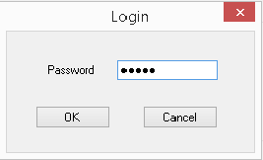
3. Select “Upgrade Firmware” and update the generator with the specific version of firmware, could be found in virtual lab system installation directory.
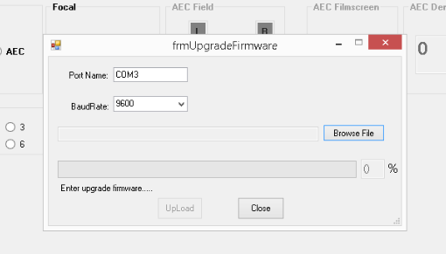
4. Select “Restore Generator Setting” from the “File” Menu, and restore the generator settings value. The settings file could be found in virtual lab installation directory.
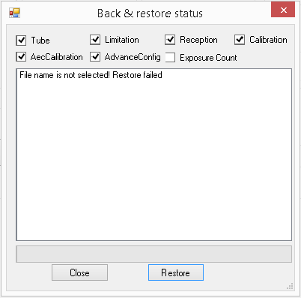
5. Select the “Station Setting” from “Setting” Menu and change the station 1 and 3 configuration as below.
Station 1:
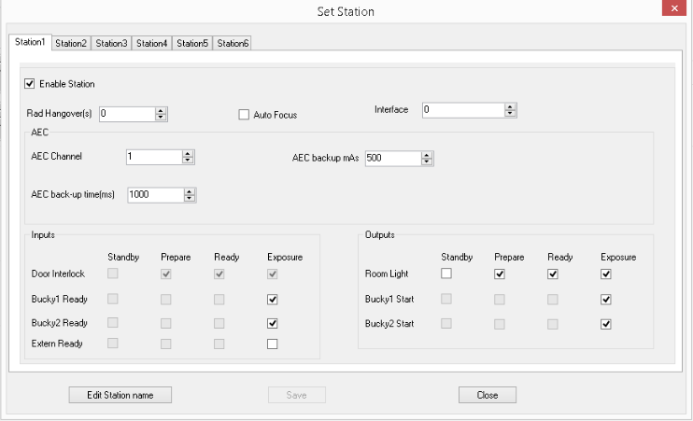

Station 3:
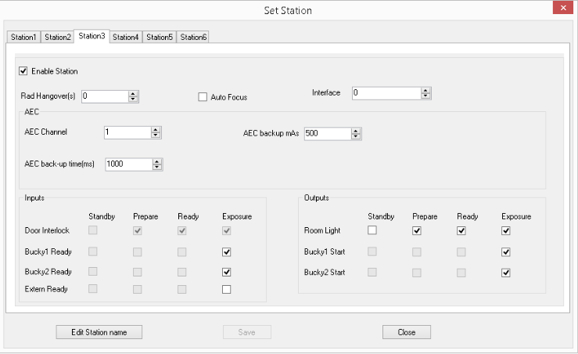

Can Analyzer Drivers
Please refer to product manual of CAN analyzer


